$ git diff = to compare different versions

$ git add = to add the files

$ git status

$ git commit -m “Update (the file).”

$ git commit –amend -m “Update (file), amend message.”

$ git commit -m “whatever name you want to use as visualization when changes are made when checking through $ status”

$ git log = to see the updates on the files

Message (nothing to commit, working tree clean) = changes were made

$ git push = to push your local changes to the online server to work collaborative

$ git pull = to get changes just made by pushing. So you have the changes in your local files

In order to clone: find the link to the online repo in GitLab page. Under “Code”, using “HTTPS”.

$ git clone (link to the HTTPS from Code in GitLab)

pwd=print working directory in the git bash

Git: Distributed Version Control System.

Distributed Version Control System: program that tracks changes in files and saves the history, allowing to check out previous stage versions of the files.

Distributed: version control is not centralized on a single machine, there are multiple copies of the files on different computers and transfer info.

Repository/repo: collection of files which history is being tracked. These files are grouped into a single folder or directory, which can also contain subdirectories.

A Git repository includes the history of the files in the repo. The history is indicated by a line, and each circle indicates a checkpoint, called a commit. Git allows more complicated revisioning in a repo using branching and merging.

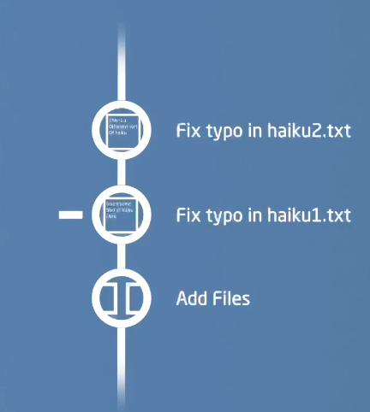

Local changes (in private computers) are updates to the online server where online files are storage for the collaborative group. The online server secure the access (not outsiders can enter it), the server has Git installed. Special features so updates can be automatically merged into the remote, this online hosting servers complies as GitLab and GitHub.

**Push**: changes to the online server

**Pull**: getting the changes previously pushed

When changes are done, it’s needed to be pulled previously to push new changes.

**Git questions to answer**

In GitAnswers.md, write 1 to 2 sentences to answer each of the following questions. (Note that for question 6 you will need to also push an image.)

1. **What is the difference between git and GitLab?**

**Git** is a free an open-source tool. Efficient and fast to use. Helps to work from small to big projects. Mostly world’s widely used for control system. Git is used in GitLab and GitHub. Git is a fully distributed system, requires local files and resources, allowing to work offline.

**Git**: is a software program that can be installed in our computer.

**GitLab/GitHub**: online hosting service that host the copy of the repo, accessible through secure internet connection.

1. **What is the difference between GitLab, GitHub, and BitBucket?**
2. **Why would I ever want to use git, but not GitLab?**

Git is used for any documents you are working with and creating, editing and reviewing, weather only you or collaborating in groups across the world. The app goes beyond the coding nowadays, for control system.

1. **What are the steps to update the GitLab server with some changes I made on my computer?**

To update the local server, it’s needed to push your local changes from the Git Bash terminal. Then your teammates have to pull in order to get in their local computer the changes.

1. **What is a branch and why would I use one?**
2. **How could you visualize a branch with 3 commits, and then another branch that breaks off after the second commit and has a single commit?**
3. **Give an example of a set of git commands that would result in a merge conflict.**

Merge conflict. It occurs a conflict when two people change conflict between each other. One person changes directly conflict with the other person changes in a local copy. Perhaps both modified the same line but in different ways. Since Git doesn’t know which changes should be caught, it’s happening a merge conflict.

1. **Is Git suitable for latex documents?**
2. **Should I from now on version my word and powerpoint slides using git? Why/why not?**
3. **What could happen when I push my latest commit to the remote repository without pulling first?**

When working in collaborative, when someone pushes first, the other person can’t push until this one pulls first the changes.

This happen because the online server compares the history in the remote with the history the second person is pushing. Since the second person’s repo is missing the recent history, the server rejects the push. The second person has to pull first, and then push yours.

1. **What happens when I pull without commiting my local changes first?**

Your changes won’t have the last update from the local history changes form the repo.

1. **What is the difference between branching and forking?**